Western Gateway Rail Strategy

Stakeholder eConsultation

Introduction

The Western Gateway Sub-National Transport Body (STB) covers a large, diverse geography and contains some of the UK’s fastest-growing sectors in a variety of locations. Given the STB’s economic potential, it is crucial that its strategic transport corridors are able to provide the best levels of connectivity possible.
The purpose of the STB is to produce a Strategic Transport Plan which will:
- Be a multi-modal strategy that considers Sub-national connectivity only;
- Identify issues and infrastructure requirements
- Complement local transport strategies to enable the delivery of shared objectives; and
- Focus on the strategic travel corridors through a series of Multi-Modal corridor studies.
The next step in the process involved a focus on rail and its role in the Western Gateway geography to develop a Rail Strategy. As part of the initial stage of this process, we are consulting key stakeholders and community groups in order to capture their views and priorities to support the development of Conditional Outputs for the Strategy.

This eConsultation contains four sections and should take 10-15 minutes to complete:
- this introduction section;
- comments on Vision and Objectives;
- a SWOT analysis of rail in the region; and
- an opportunity to provide any other comments.
The deadline to submit this eConsultation is 31 December 2019.
- Please enter your full name

- Which organisation do you represent?

- What is your role or title in your organisaion?

- Please enter your email address if you would like to be kept up to date about the outcomes of this eConsultation and the Rail Strategy development.

GDPR statement: by providing your personal data you are consenting to be contacted by either the Western Gateway Steering Group, consisting of the nine local authorities listed above, or the consultants WSP who are leading the engagement and Rail Strategy development. Your information will never be passed on to a third party and will be deleted after the completion of the Rail Strategy.

Strategic Objectives
In this section we would like you to think about the key impacts that this Rail Strategy should aim to achieve, and this will support the development of our Vision and Objectives. At the bottom, there is an open field for you to compose a response capturing your views and aspirations for rail in the region.

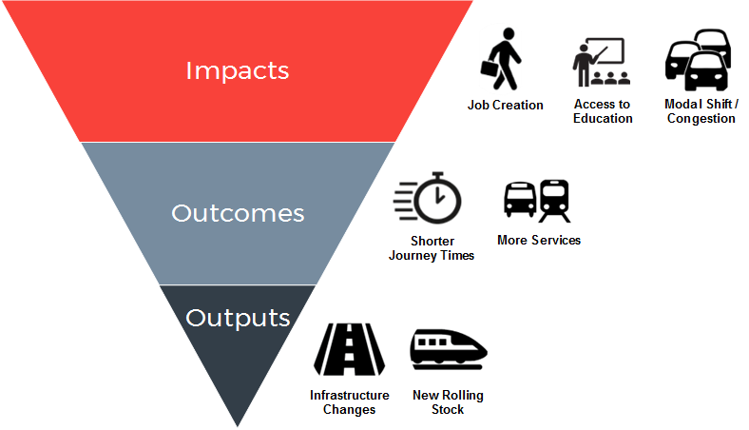
For this response, we would like you to focus on the high-level impacts and how society will benefit to an improved rail service provision, rather than a discussion of specific outputs that might be made to achieve this.

We would like you to consider not only journeys within the Western Gateway area but also (and crucially) cross-border connectivity to neighbouring regions. The main passenger rail lines are indicated in the image below.

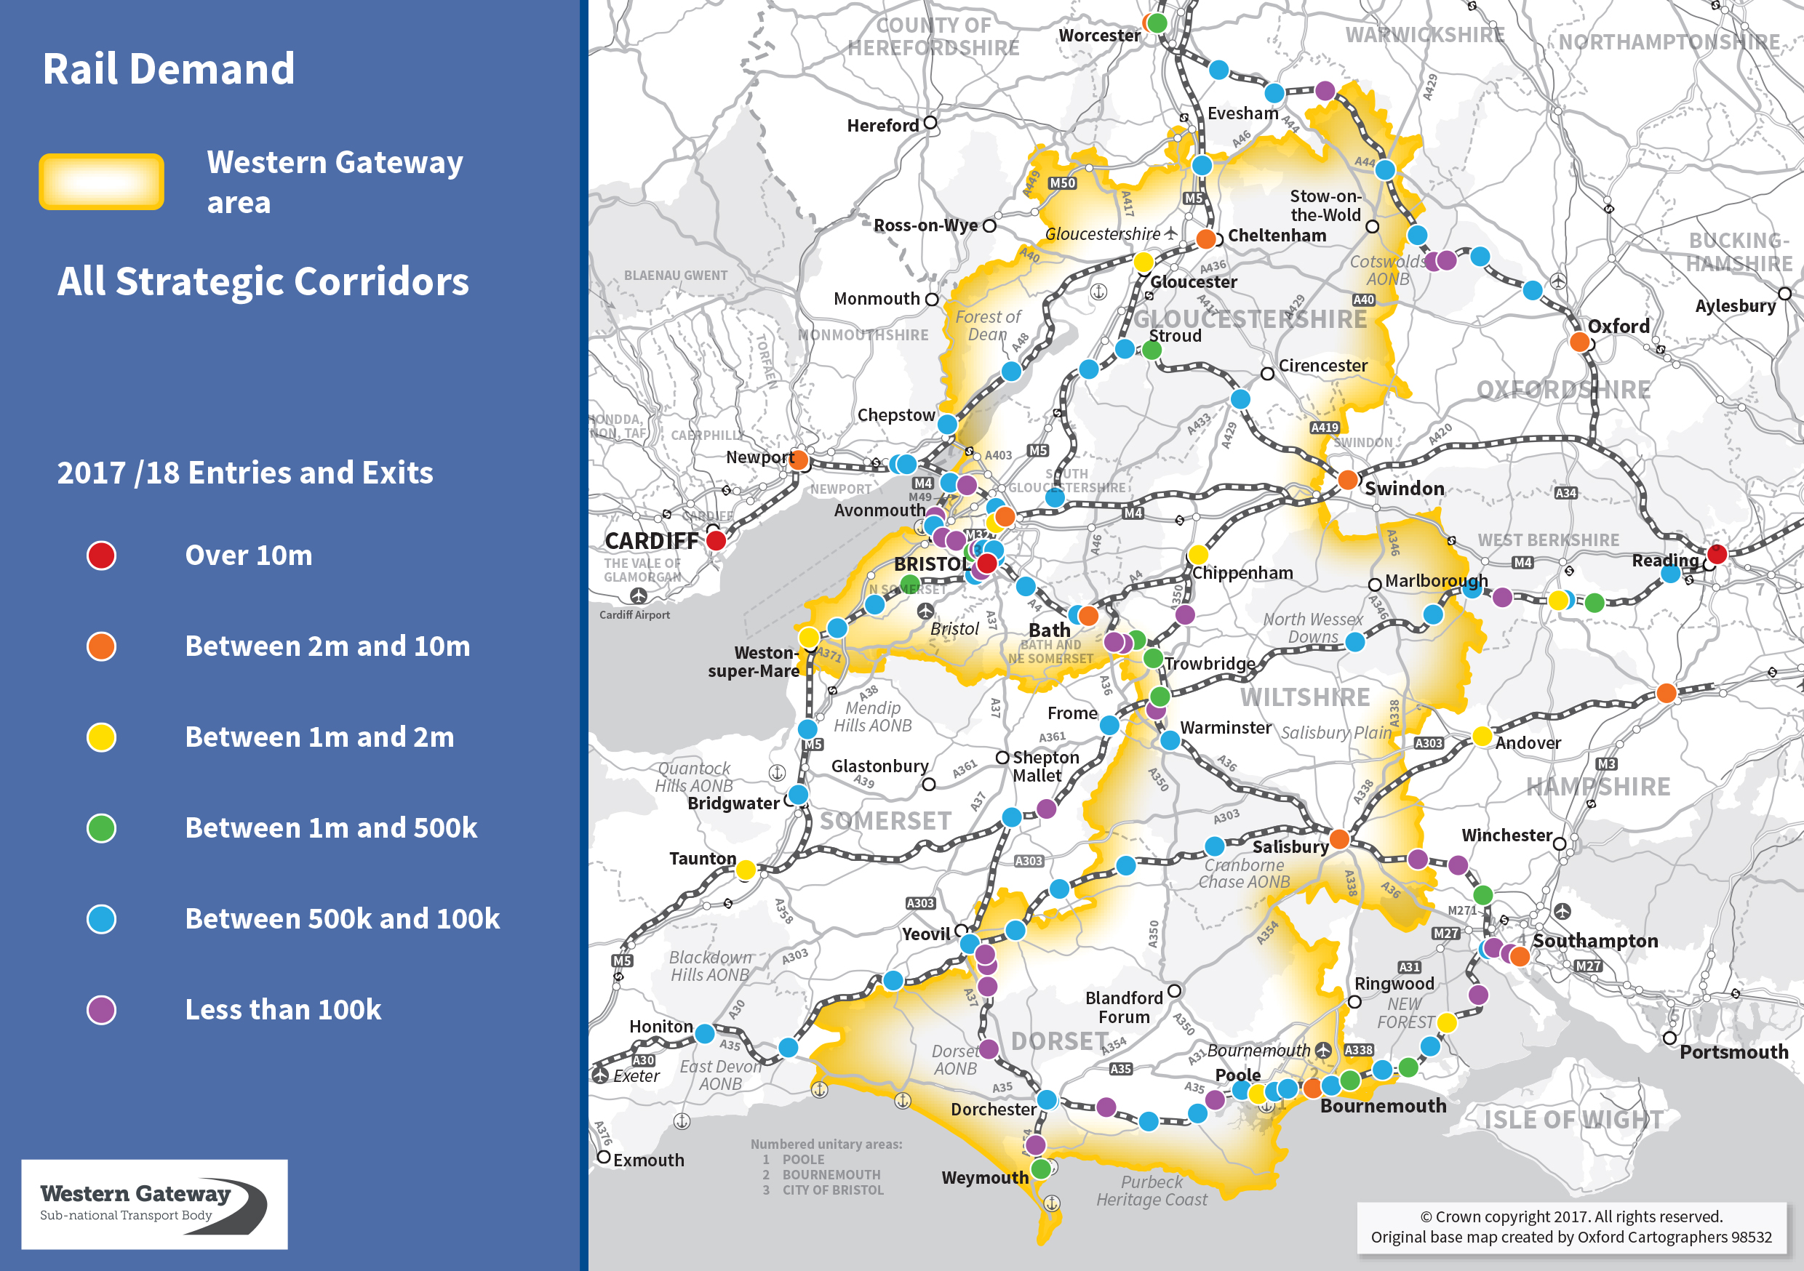

Strategic Objectives
- What high level impacts would you or your organisation like to see incorporated and addressed as part of this Rail Strategy?

- Connectivity (and therefore improved utility) with wider public transport system (i.e multi-modal, including rail).
- Connectivity between principal centres of demand (e.g. agglomerations, airports) and with hubs serving groups of more dispersed settlements.
- Resilience and reliability.
- Sufficient capacity to enable people to travel comfortably at times of peak demand.
- Environmentally sustainable (e.g. an attractive alternative to car travel; minimal emissions).
- Accessible to people with reduced mobility (therefore all) – physical infrastructure, assistance and jouney information, including real-time data supply.
- Turn-up-and-go service frequencies.
- Backbone for spatial planning.

Constraints and Opportunities
In this section we would like you to think about the Strengths, Weaknesses, Opportunities and Threats regarding the Rail network in the Western Gateway.

- What do you think are the strengths of the rail network in the Western Gateway today?
- Useful strategic transport corridors - both East--West and North-South – with scope for enhancement and development.
- GWML up-grade planned in way that makes provision for further electrification.
- The principal operator serving the Western Gateway (GWR) has a track record of constructive working institutionally with the communities that it serves (e.g. Regional Development Managers).

- What do you think are the weaknesses of the rail network in the Western Gateway today?

- Poor North-South connectivity (e.g. Swindon-Southampton; Bournemouth – Bristol) and limited East-West connectivity for southern part of region (e.g. South Coast through sevices between Sussex/Hants and Somerset/Devon).
- Poor connectivity with airports (eg LHR, BRS. EXE, SOU, BOH, BXH).
- Poor reliability and resilience, particularly on those routes where infrastructure capacity was cut back in the 1960s and 1970s (e.g. Weymouth-Poole. Salisbury-Exeter, Chippenham-Westbury, Dorchester-Westbury, Bradford-upon-Avon- Melksham (removal of track on chord between Bradford-upon-Avon and Holt – the Box Tunnel avoiding line chord)).
- Pockets of poor connectivity on existing network, particularly when there are infrastructure or operational constraints on meeting conflicting market needs (e.g. the Westbury hub, which suffers from reduced connectivity with the far south west because the dominance of the Peninsula Rail Task Force lobby means that faster London-Plymouth journey time consuderations mean that fewer attractive Far South West connections are now provided at the Westbury hub).
- Capacity pinch-points, particularly at peaks and at times of engineering possessions (e.g. reductions in, or operational limitations on, platform capacity at Westbury, Gloucester, Chippenham, Salisbury, Bath).
- Relatively low status as to frequencies, jouney speeds and rolling stock of servies other than those using the up-graded sections of the Network Rail’s Western route and the section between London and Poole of its Wessex Route South Western Main Line. (The route via Westbury linking the Severn with the Solent was originally classified as an InterCity route.)
- Network connectivity hampered by poor integration of rail and bus/coach services and the absence of user-friendly rail-road interchanges at major hubs.
- Lack of adequate staff or ‘trusted person’ presence at many stations (e.g. food points, community facilities, etc.)
- Poor public transport information provisiion.
- Lack of multi-modal ticketing schemes.
- Reliance of diesel traction.

Constraints and Opportunities
In this section we would like you to think about the Strengths, Weaknesses, Opportunities and Threats regarding the Rail network in the Western Gateway.

- What opportunities do you think there are for rail in the Western Gateway?
- The rail rights of way already exist
- A step-change in environmental awareness and the relevance of greater public transport use as an alternative to private motoring. This relates to the reducted emissions, reducing congestion, optimising land use and improved management of public resources.
- An increasing awareness that spatial planning should be integrated with transport planning.
- Demographic changes that are likely to increase pressure for accessible public transport (especially the disproprtionately large aging population in the sub-region).
- The likelihood that increased housing demand will create an environment more favourable to public transport if it is to be accommodated without unacceptable levels of congestion and land take for additional road capacity.

- What do you think are the greatest threats ﻿for rail in the Western Gateway?
- Lack of support at the political level.
- Pressure on local authority resources leading to limited transport expertise within individual authorities.
- Inadequate engagement between operators and even within operators on exploitation of potential cross-modal opportunities.
- A tendency – possibly reinforced by uncoordinated demands from central Government – to adopt a mono-modal, silo-like approach to the planning of strategic corridors.
- The non-synchronous nature of the different planning and funding timescales for different modes meaning a lack of an integrated approach to mobility planning.
- A failure to consult with and generally draw on the expertise, needs and aspirations of transport system users.

Further Comments
This section will allow you to provide any further comments in text form, or upload supplementary documents or reports for us to capture as part of our Rail Strategy.
- Do you have any further comments - specific to your organisation or otherwise - regarding rail in the Western Gateway area?

